Name: k.sanjana
Roll No: 2505A41L63
Q1. Flatten a Linked List
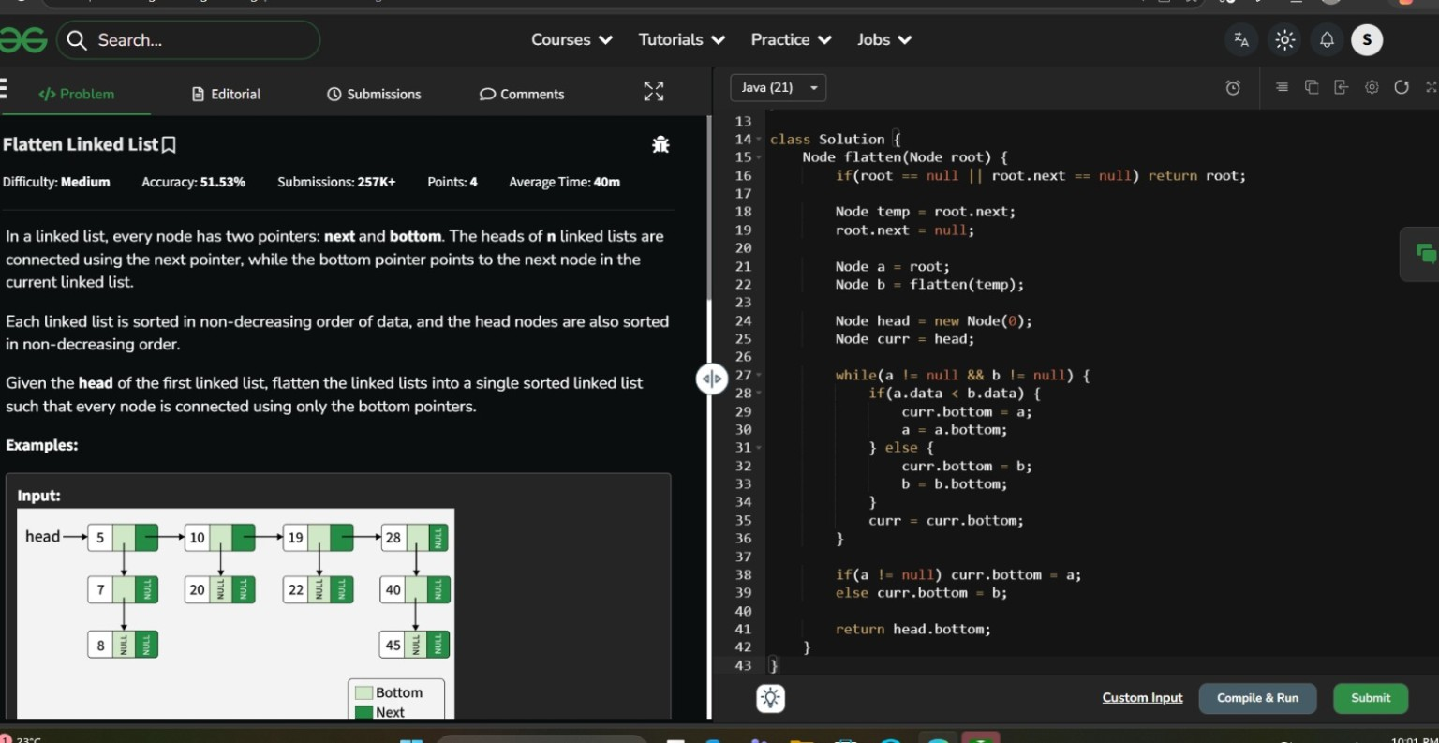
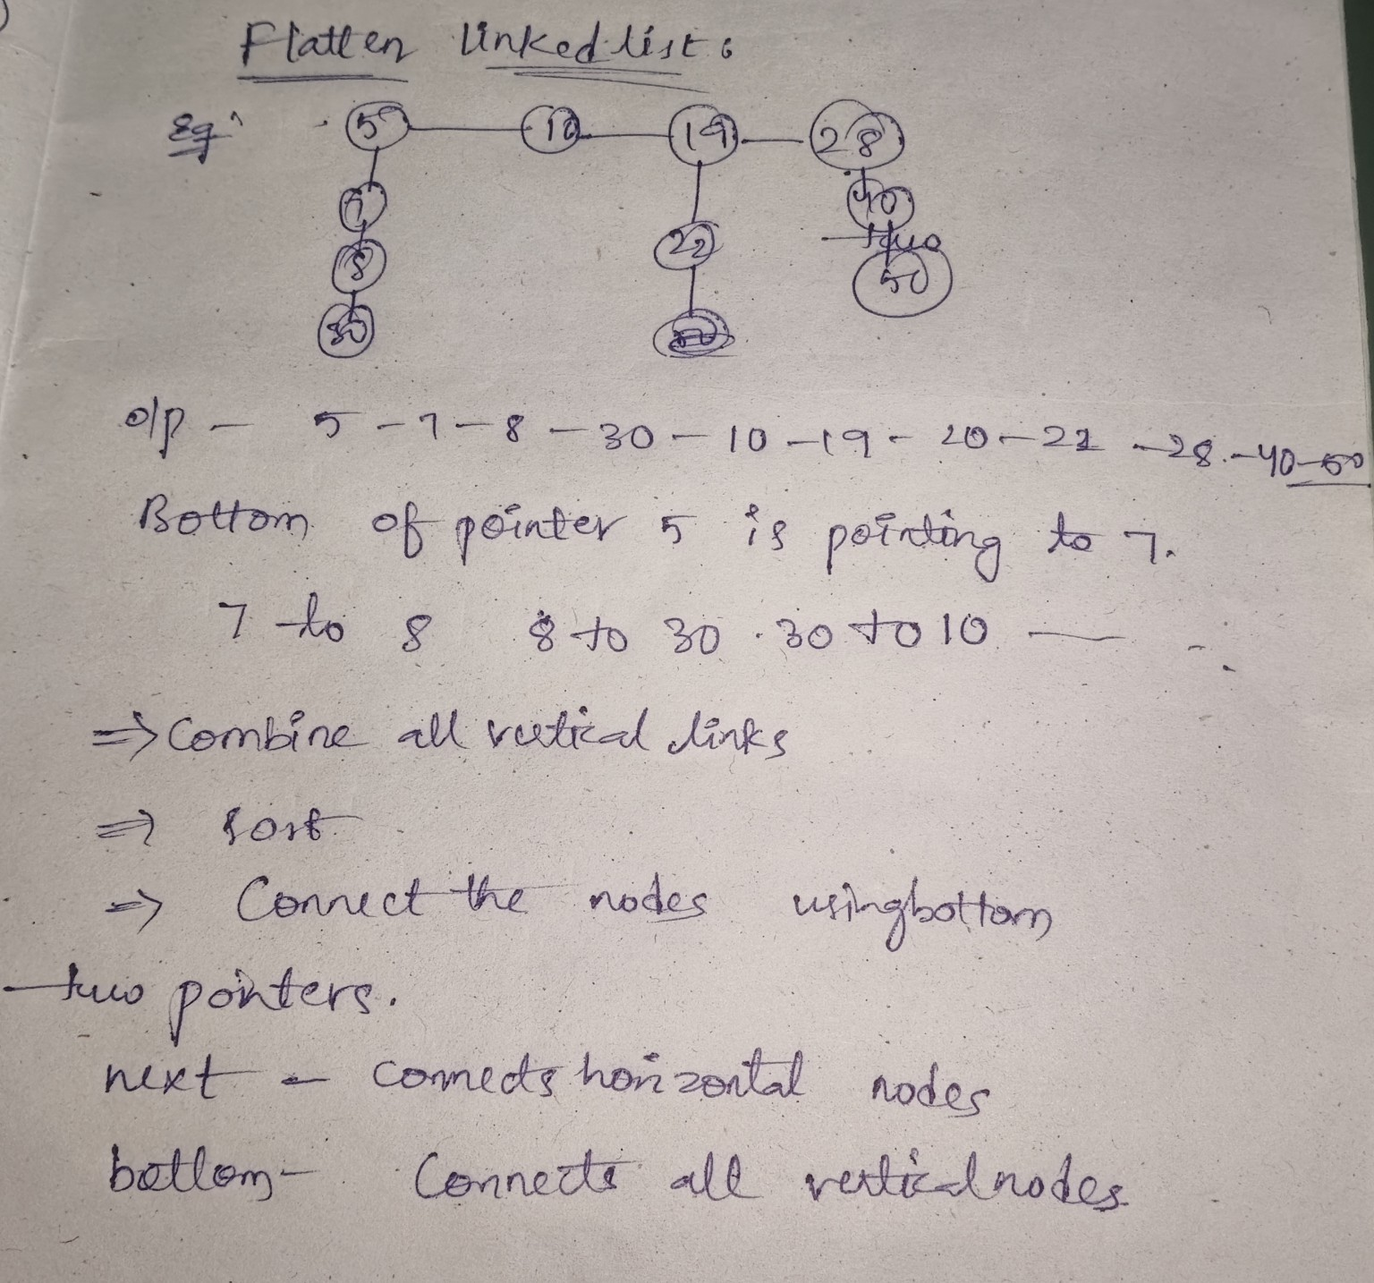
LeetCode link: https://www.geeksforgeeks.org/problems/flattening-a-linked-list/1

Q2. Rotate List
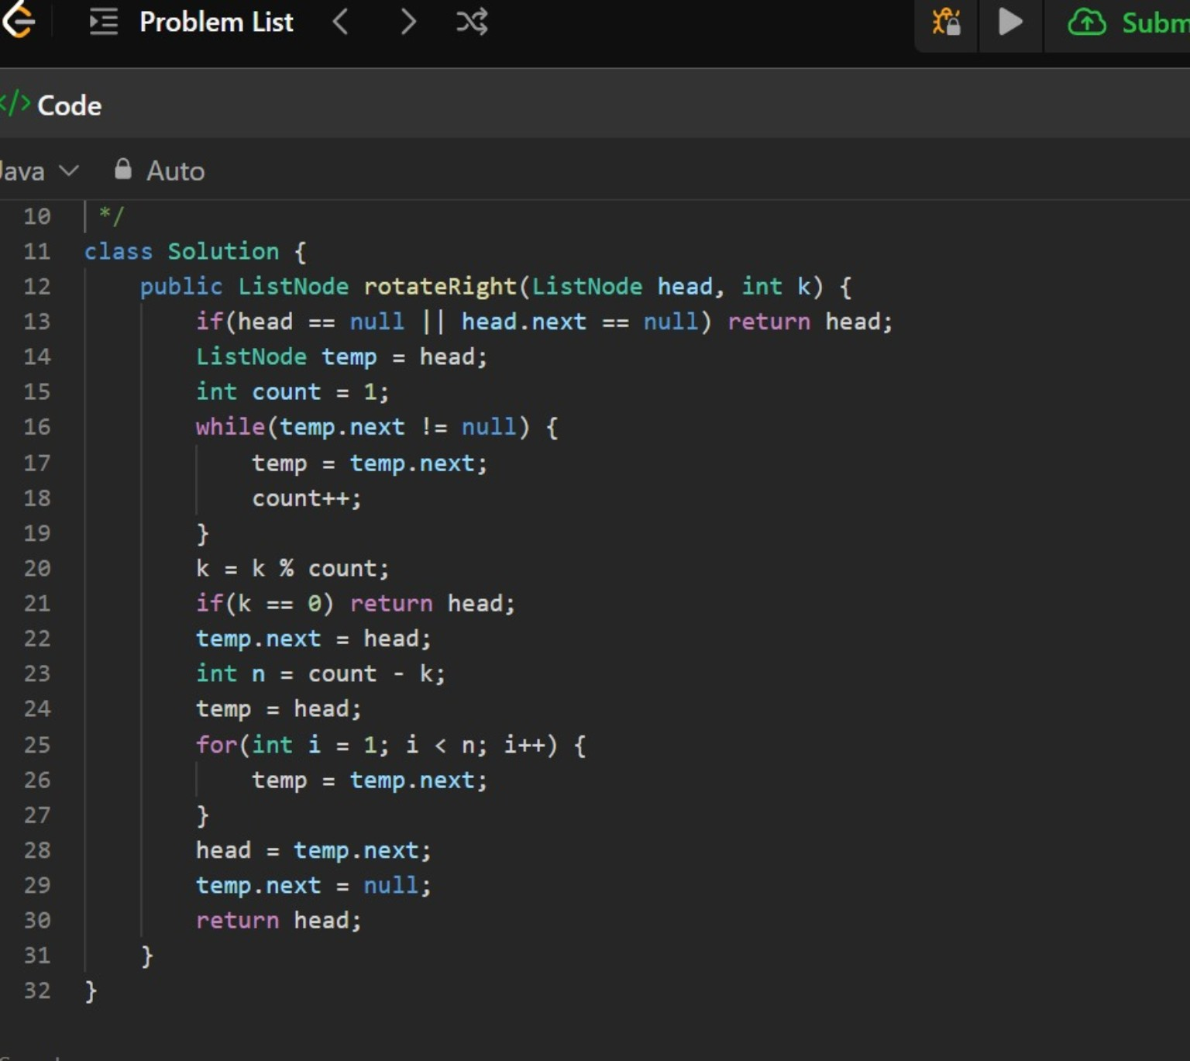
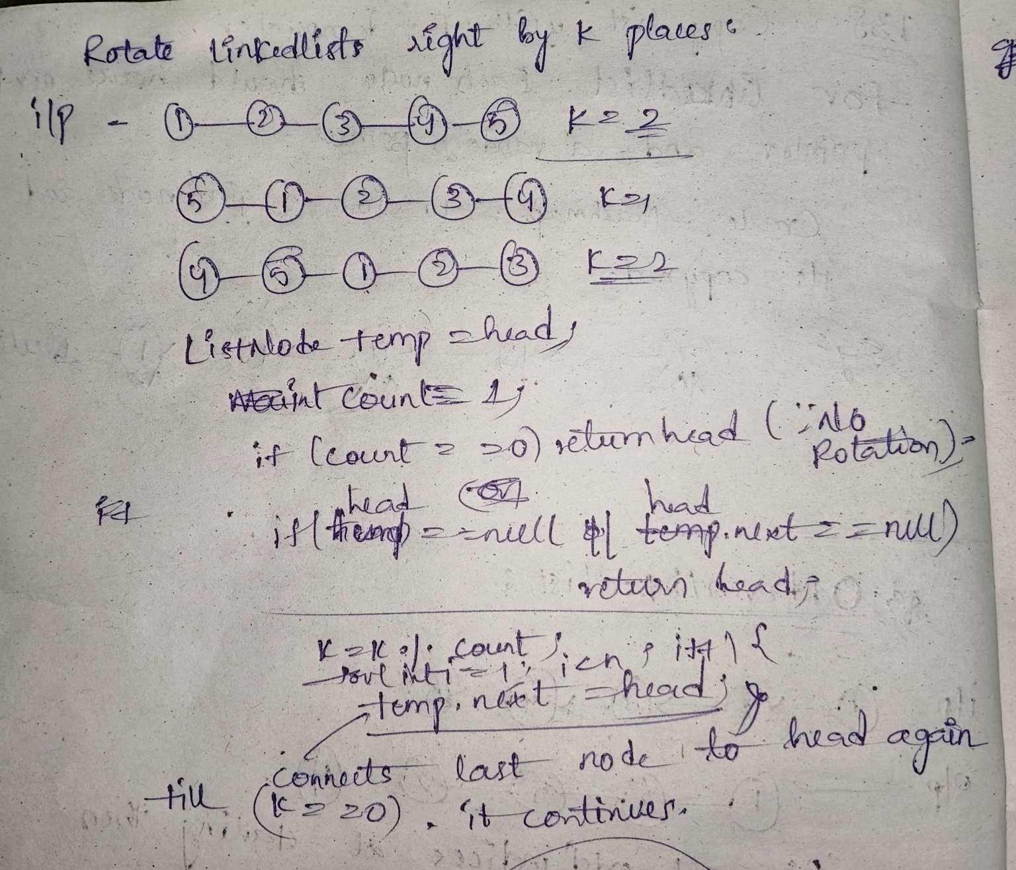
LeetCode link: https://leetcode.com/problems/rotate-list/

Q3. Odd Even Linked List
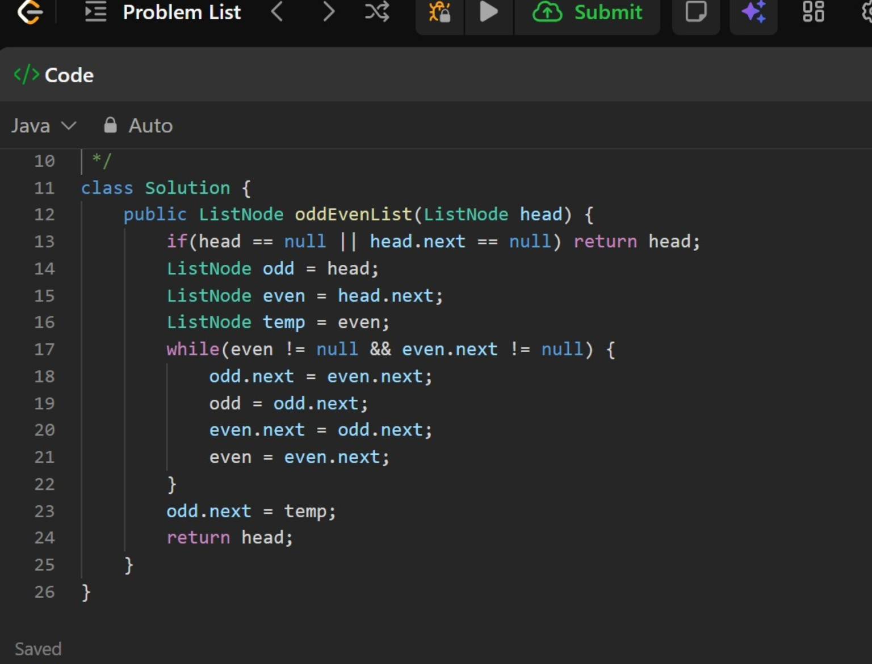
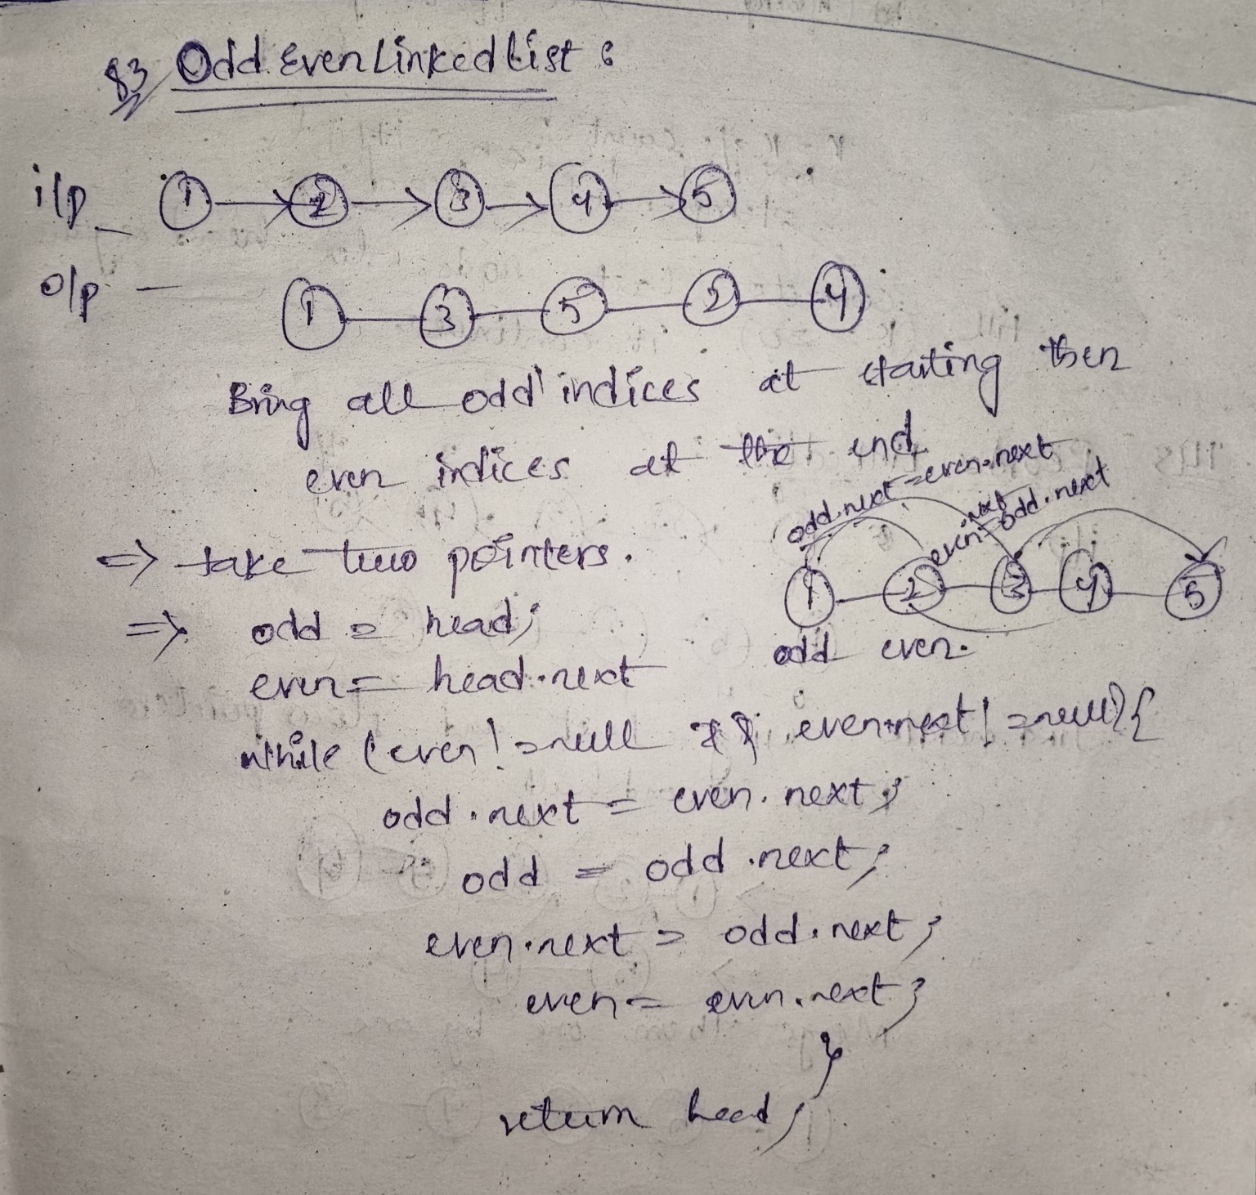
LeetCode link: https://leetcode.com/problems/odd-even-linked-list/

Q4. Reorder List
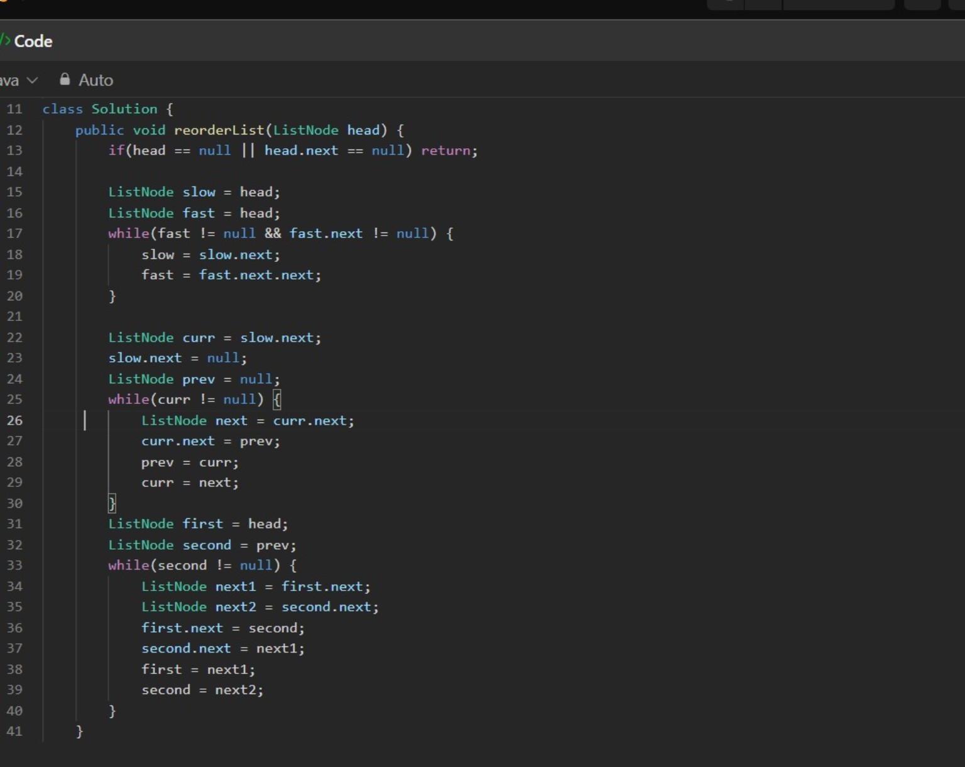
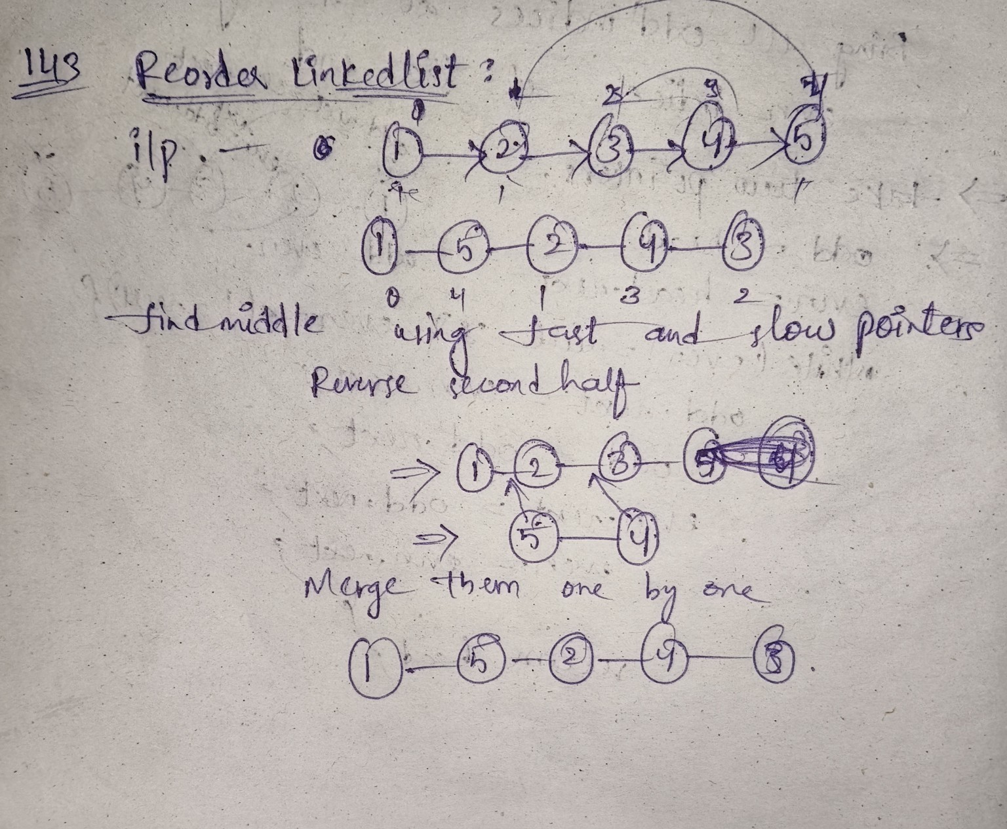
LeetCode link: https://leetcode.com/problems/reorder-list/

Q5. Pairwise Swap in Linked List
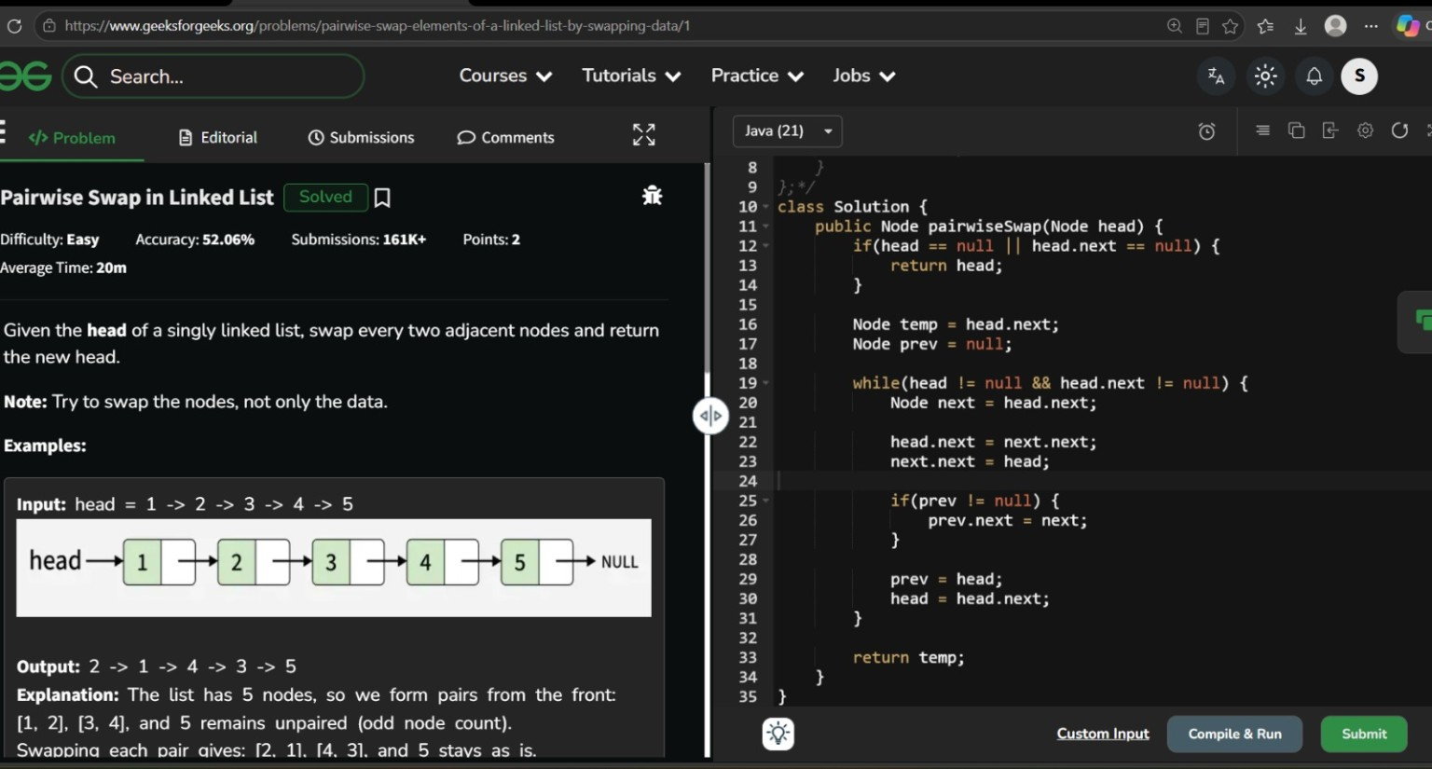
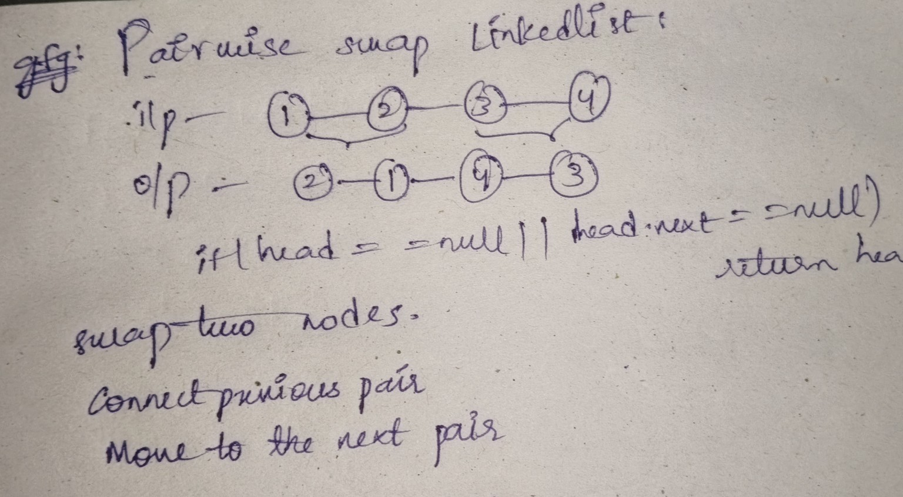
LeetCode link: https://www.geeksforgeeks.org/problems/pairwise-swap-elements-of-a-linked-list-by-swapping-data/1

